**IDENTIFYING THE AREA**

**PHASE-1 (Leading Company)**

1. Area of interest : Electric vehicles

2. Leading Companies in the area :Tesla , TATA , BMW , waymo , JAC , GEELY, Hyundai,ZD, Renault-Nissan

3. Select One of the Company : Tesla

4. Read the latest three years report: report of year which i read 2019,2018,2017.

**Annual report of the year 2019**

financial data of the year 2019

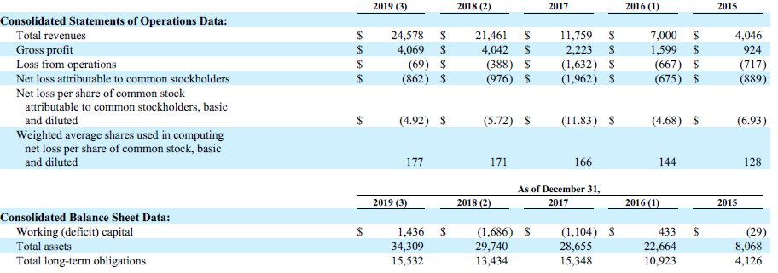

**Area of focus**

Our Model 3 production ramped dramatically during 2018, and we expect to continue to grow Model 3 production to a sustained rate of 7,000 vehicles per week at our Tesla Factory by the end of 2019 as we ramp international deliveries. We expect to build a production process that is optimized and simplified for Model 3 production, consisting of stamping, body joining and paint shops and general assembly, at Gigafactory Shanghai to begin production of certain trims of Model 3 for China by the end of 2019. We also recently discontinued new custom orders for the 75 kWh versions of Model S and Model X to focus on longer range versions of our highest performance flagship vehicles and further differentiate them from Model 3.

**Accomplishments in that year**

During 2019, we achieved annual vehicle delivery and production records of 367,656 and 365,232 total vehicles, respectively. We also laid the groundwork for our next phase of growth with the commencement of Model 3 production at Gigafactory Shanghai. We also continued to enhance our user experience through improved Autopilot and FSD features, including the introduction of a new powerful on-board FSD computer and a new Smart Summon feature, and the expansion of a unique set of in-car entertainment options. Our solar deployments grew approximately 48% and 26%, quarter-over quarter, in the second half of the year. We also deployed 1.65 GWh of energy storage in 2019, more than the aggregate of all prior years.

**Future are of interest**

A key focus in 2020 will be our efforts towards establishing and expanding capacity for vehicle production at volume across three continents. At the Fremont Factory, we commenced Model Y production earlier than anticipated, and combined with Model 3, we have installed annual production capacity for 400,000 vehicles. We expect to further increase this capacity to 500,000 vehicles through the installation of additional equipment processes. We have commenced construction of the next phase of Gigafactory Shanghai to add Model Y manufacturing capacity at least equivalent to that for Model 3. To finance our construction and expansion, in December 2019 our local subsidiary entered into a RMB 9.0 billion (or the equivalent amount in U.S. dollars) fixed asset term facility and a RMB 2.25 billion (or the equivalent amount in U.S. dollars) working capital revolving facility, part of which was used to repay a RMB 3.5 billion bridge loan entered into in March 2019. We are supplementing such financing with limited direct capital expenditures.

**Annual report of the year 2018**

financial data of the year 2018

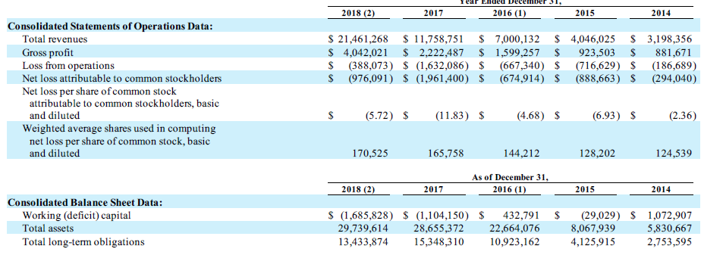

**Area of Focus**

According to Tesla ,Our mission is to accelerate the world’s transition to sustainable energy. We design, develop, manufacture, lease and sell high-performance fully electric vehicles, solar energy generation systems and energy storage products. We also offer maintenance, installation, operation and other services related to our products. For the year 2018 they were focussing on the ,They were focussing on increasing the production of the different models they have designed so far. Targeting the audience so that they can buy them . They expect Model 3 production and deliveries to grow significantly in 2018. They expect Model S and Model X deliveries to be approximately 100,000 in total in 2018, constrained by the supply of cells with the 18650 form factor used in those vehicles .Based on their current progress, we are targeting a production rate of 2,500 Model 3 vehicles per week by the end of the first quarter of 2018 and 5,000 .Model 3 vehicles per week by the end of the second quarter.In order to optimize the incremental improvement of our automation processes and the efficiency of our capital expenditures, we will implement the capacity to further ramp production to 10,000 units per week only after we have achieved a 5,000 units per week run rate. They expect energy storage products to experience significant growth, with our aim being to at least triple our sales in 2018.We plan to adopt the new revenue recognition standard ASC 606 effective January 1, 2018.

**Accomplishments in that year**

In 2018, we continued to scale our automotive operations, particularly our ramp of Model 3, and achieved total production of 254,530 vehicles and delivered 245,506 vehicles, representing year-over-year increases of approximately 152% and 138%, respectively. We lease and sell retrofit solar energy systems and sell renewable energy and energy storage products to our customers, and are ramping our Solar Roof product that combines solar energy generation with attractive, integrated styling. Our energy storage products, which we manufacture at Gigafactory 1, consist of Powerwall, mostly for residential applications, and Powerpack, for commercial, industrial and utility-scale applications. During 2018, we deployed 1.04 GWh of energy storage products, nearly tripling our 358 MWh of energy storage deployments during 2017. We also deployed 326 megawatts (“MW”) of solar energy generation during 2018.

**Future area of interest**

Our goal is to produce the world’s highest quality vehicles as quickly and as cost-effectively as possible with a priority on workplace health and safety. Our Model 3 production ramped dramatically during 2018, and we expect to continue to grow Model 3 production to a sustained rate of 7,000 vehicles per week at our Tesla Factory by the end of 2019 as we ramp international deliveries. We expect to build a production process that is optimized and simplified for Model 3 production, consisting of stamping, body joining and paint shops and general assembly, at Gigafactory Shanghai to begin production of certain trims of Model 3 for China by the end of 2019. We also recently discontinued new custom orders for the 75 kWh versions of Model S and Model X to focus on longer range versions of our highest performance flagship vehicles and further differentiate them from Model 3. We have an agreement with the SUNY Foundation for the construction of a factory with the intended capacity to produce at least 1.0 GW of solar products annually in Buffalo, New York, referred to as Gigafactory 2.

**Comments**

It is pretty clear that tesla was capable of completing their goals.

**Annual report of the year 2017**

Annual report of the financial year 2017

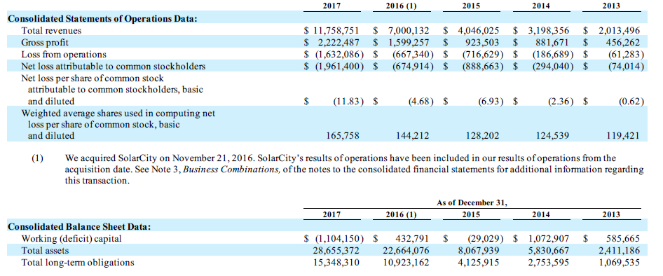

**Area of Focus**

In order to accommodate a much larger fleet of customer vehicles as we increase deliveries and to provide timely customer service, we are expanding our sales, service and charging infrastructure worldwide.In particular, we continue to open new Tesla retail and service locations around the world. As of December 31, 2016, we had a total of 265 sales and service locations, and expect our long-term vehicle sales outside of North America to be over half of our worldwide total automotive revenue. We plan to reduce customer acquisition costs by cutting advertising spend and increasingly selling solar products in Tesla stores. We plan to build 500,000 vehicles in 2018. Given this plan, we continue to invest heavily in capital expenditures. Our capital expenditure needs include expenditures for the tooling, production equipment and construction of the Model 3 production lines, equipment to support cell production at the Gigafactory 1, as well as new retail locations, service centers and Supercharger locations. We expect to invest between $2.0 billion and $2.5 billion in capital expenditures ahead of the start of Model 3 production in 2017.

**Accomplishments in that year**

In 2017, our vehicle production capability continued to scale and gain operational efficiencies, and vehicle production volume increased by 20% year-over-year. Additionally, we delivered 101,420 Model S and Model X vehicles and 1,764 Model 3 vehicles in 2017. We lease and sell solar energy systems and sell renewable energy and energy storage products to our customers.In late 2017, we completed installation of the largest battery in the world in South Australia. This battery delivers electricity during peak hours to help maintain the reliable operation of South Australia’s electrical infrastructure.In 2017, we deployed 358 MWh of energy storage products and 523 MW of solar energy generation.

**Future area of interest**

We expect Model 3 production and deliveries to grow significantly in 2018.Based on our current progress, we are targeting a production rate of 2,500 Model 3 vehicles per week by the end of the first quarter of 2018 and 5,000.Model 3 vehicles per week by the end of the second quarter. we will implement the capacity to further ramp production to 10,000 units per week only after we have achieved a 5,000 units per week run rate. We are continuing to reduce customer acquisition costs of our energy generation products, including by cutting advertising spend and increasingly selling these products in Tesla stores with dedicated energy product sales personnel and leveraging channel partnerships. Moreover, we have deemphasized absolute volume growth for our solar products, and we have instead prioritized projects for cash generation and profitability. Solar Roof installations will initially ramp slowly in the first half of 2018. higher-margin commercial solar projects and a more profitable energy storage business due to overall cost and manufacturing efficiencies from scaling.